Setup UI Flows Environment

Ref: <https://docs.microsoft.com/en-us/power-automate/ui-flows/setup>

**Prerequisites**

* A device that runs Windows 10 Pro, Windows Server 2016, or Windows Server 2019.
* The Microsoft Edge or Google Chrome browser.
* An environment with a Common Data Service database.

**Limitations**

You must have the latest versions of each components to record, test, or run UI flows.

The following are not supported:

* Windows 10 Home installations are not supported.
* Desktop UI Flows
  + Multiple monitors
  + Double click, mouse hover, touch/pen input
  + Interactions on Windows (File explorer, startup menu, task bar, etc.)
* Web UI Flows
  + Right click
  + User session information (e.g.: cookies) will not be reused during playback. You will have to edit the script to embed sign in information when required by websites.#

**Setup Environment**

**Step 1**

Install UI flows on your device

1. [Download the UI flows installer](https://go.microsoft.com/fwlink/?linkid=2102613)
2. Activate the UI flows browser extension

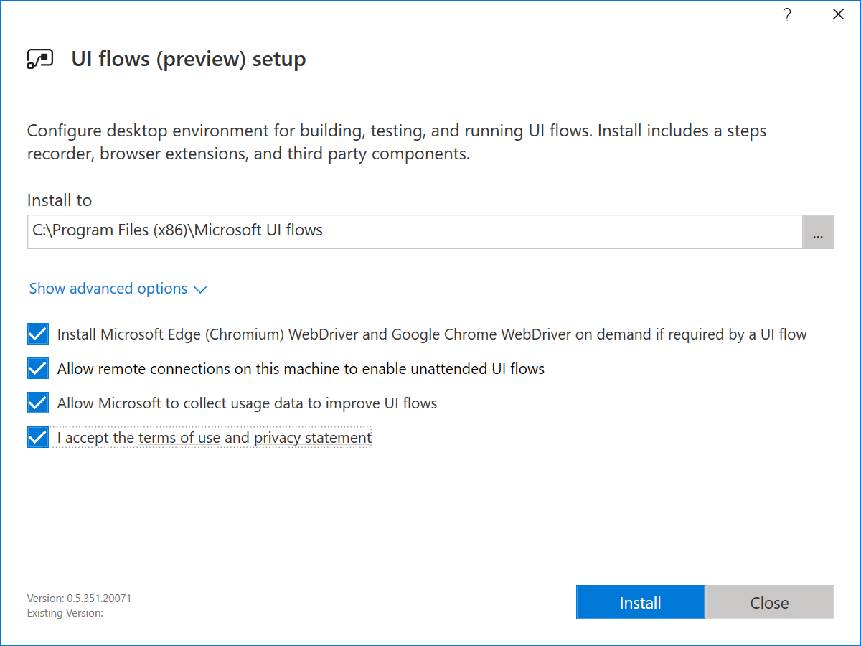

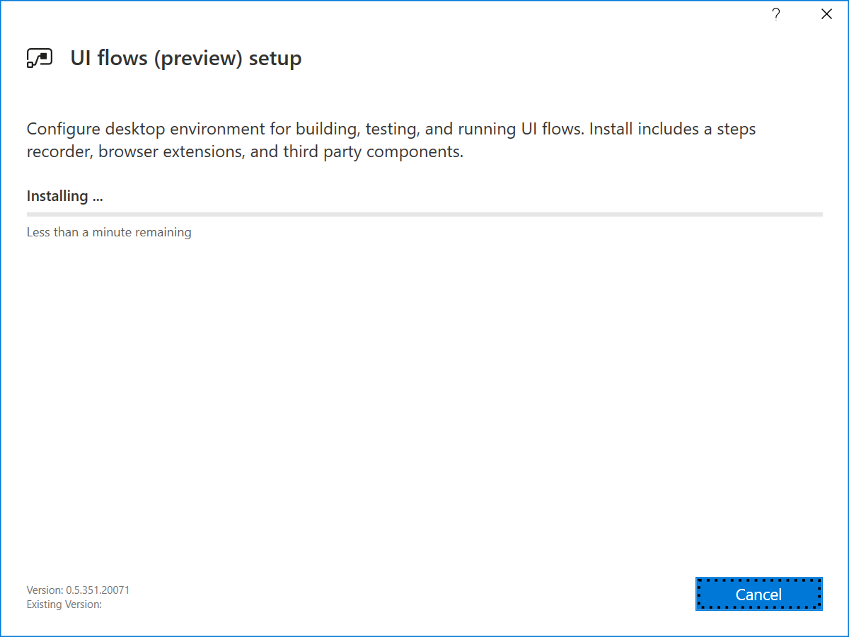

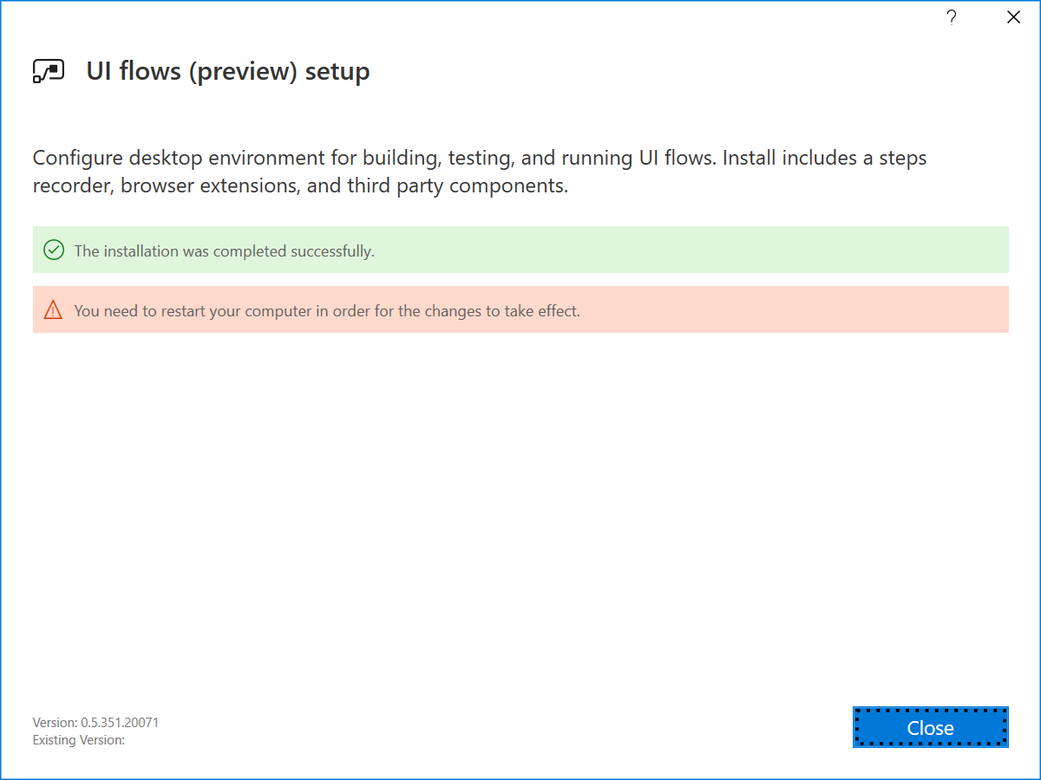

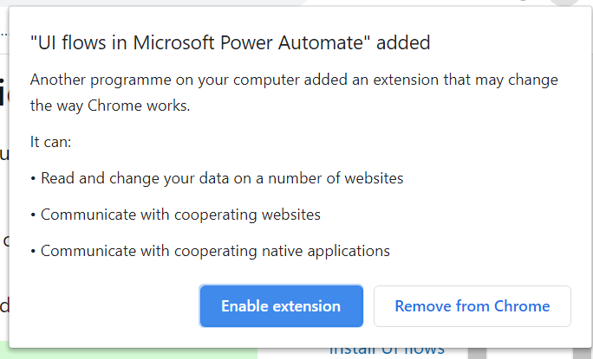

**Step 2**

* Install Selenium IDE to automate Web applications
  + [Download and install](https://chrome.google.com/webstore/detail/selenium-ide/mooikfkahbdckldjjndioackbalphokd) the Selenium IDE for the next version of Microsoft Edge or Google Chrome.
* [Install the on-premises](https://docs.microsoft.com/data-integration/gateway/service-gateway-install) data gateway
  + Recommend
    - An 8-core CPU
    - 8 GB of memory
    - A 64-bit version of Windows Server 2012 R2 or later
    - Solid state drive (SSD) storage for spooling.
  + [Download and install a standard gateway](https://go.microsoft.com/fwlink/?LinkId=2116849&clcid=0x409)